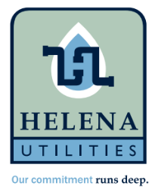
Helena Utility Board April 10, 2023

Meeting Called to Order

Prayer

Approve/Correct: Minutes (March 13, 2023)

Approve/Deny: Bill Payment

Highway 13 Main Waterline Update

Capital Projects Update

Superintendent Update

Next Meeting
Monday May 8, 2023 4:00pm

