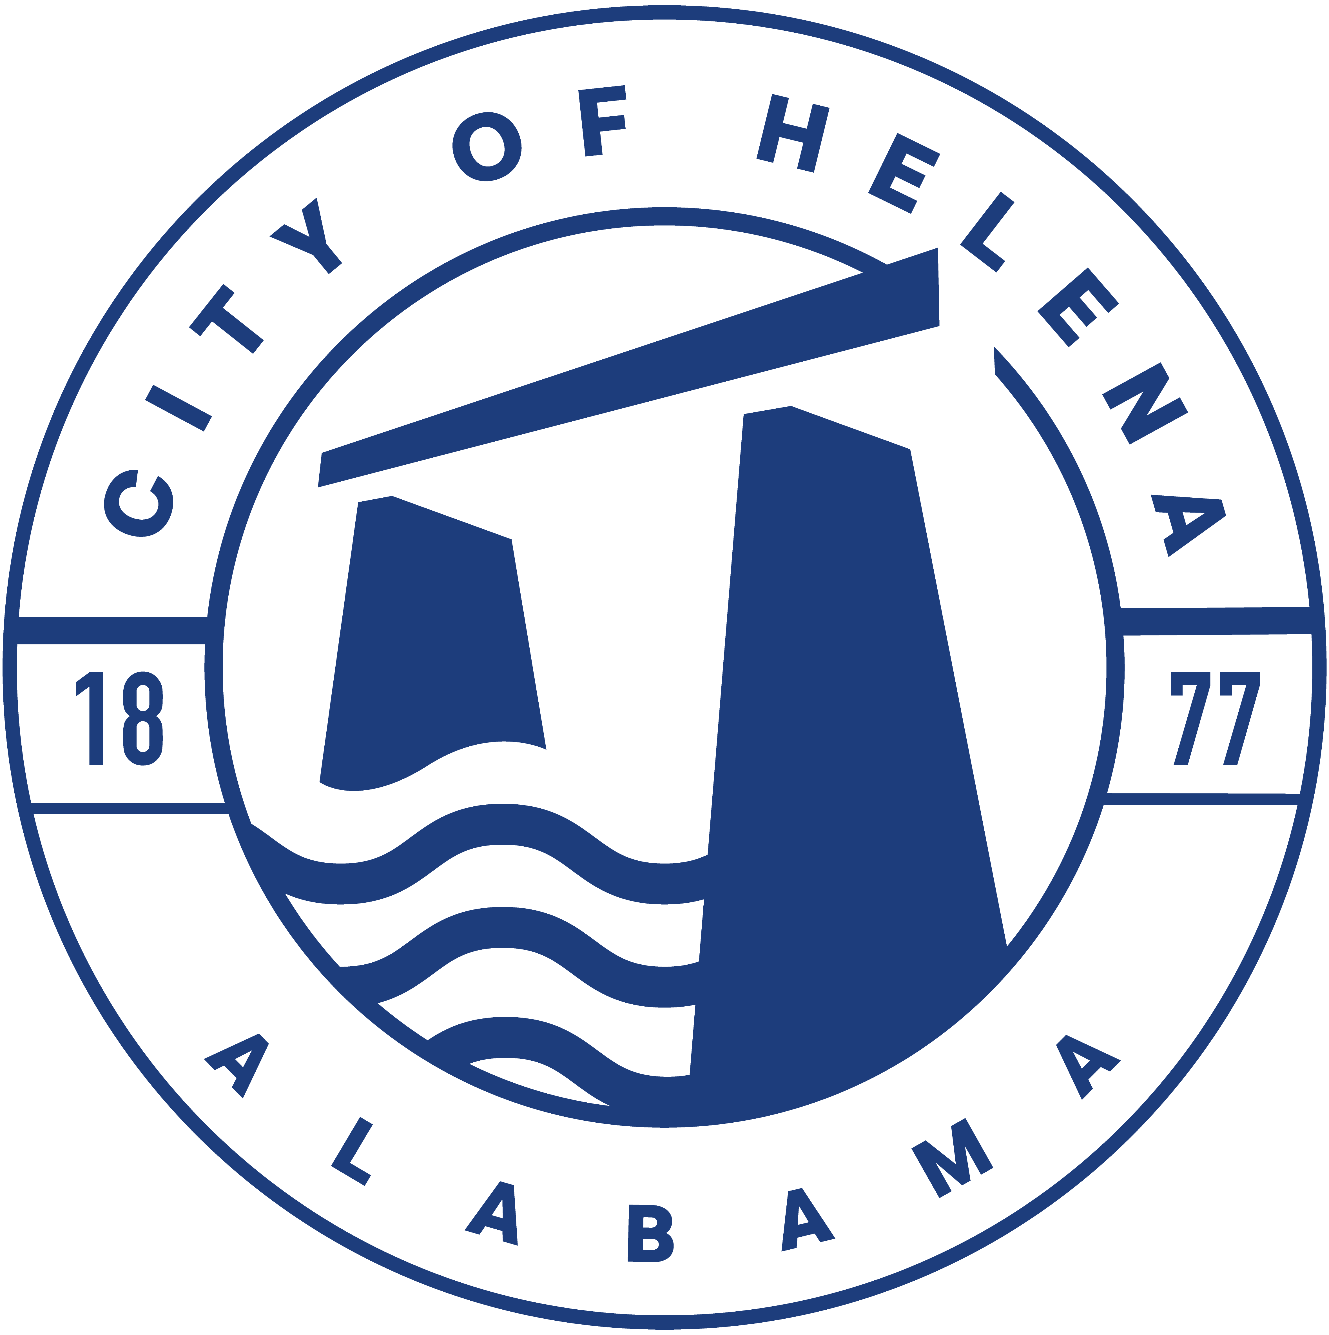
816 Hwy 52 East, Helena AL 35080
City Hall Council Chambers

Helena City Council April 24, 2023
Council Work Session 5pm
- Review of all the 04/24/2023 Agenda Items
  - AP/Bill Payments
  - 4/10/2023 Meeting Minutes Review
- Update from Council Boards and Committee Business
- Mayor’s Update
- Ordinance 912-2023-Superseding Ordinance 761-08-Council Procedures
- National Fitness Campaign Presentation
- Jordan Hosey-Buck Creek BNB-Incentive Request
- Confirmation of the 05/08/2023 Regular Meeting

City Council Meeting Agenda 6pm
- Meeting Called to Order
- Invocation
- Pledge of Allegiance
- Council Roll Call
- Presentation of Minutes from 04/10/2023
- Revenue Report and (AP) Bill Payment
- Municipal Operations Report: Mayor J. Brian Puckett
  - Departments: Police, Fire, Library, Parks, Public Works, Inspections, Sanitation, and Utilities
- Recognition of HOSA (Health Occupations Students of America) Students- 1st Place in Sports Medicine and served as the HOSA Vice President- Foster Johnson. 1st Place in EMT- Parker Agee, and Brandon Williams. Also, Michael Harrison took 4th Place in the State Competition.
- First Reading Ordinance 912-2023 Council Procedures- This will supersede Ordinance 761-08
- Approve/Deny: DIRECTV, LLC-Second Addendum to Video Services Agreement
- Approve/Deny: National Fitness Campaign
- Council Comments
- Adjournment

Proper notice of the posted Agenda for the Pre-Council Work Session and Regular Scheduled Meeting of the Helena City Council was given in advance of such a public meeting and the notice remained posted through the scheduled meeting. By general consent of the Council, agenda items may be added, removed, or considered out of order. Next City Council Meeting Date: Next Regular Scheduled Meeting will be May 8, 2023 @ 5pm Work Session followed by Regular Meeting at 6:00pm.

Updated: 4/21/2023

