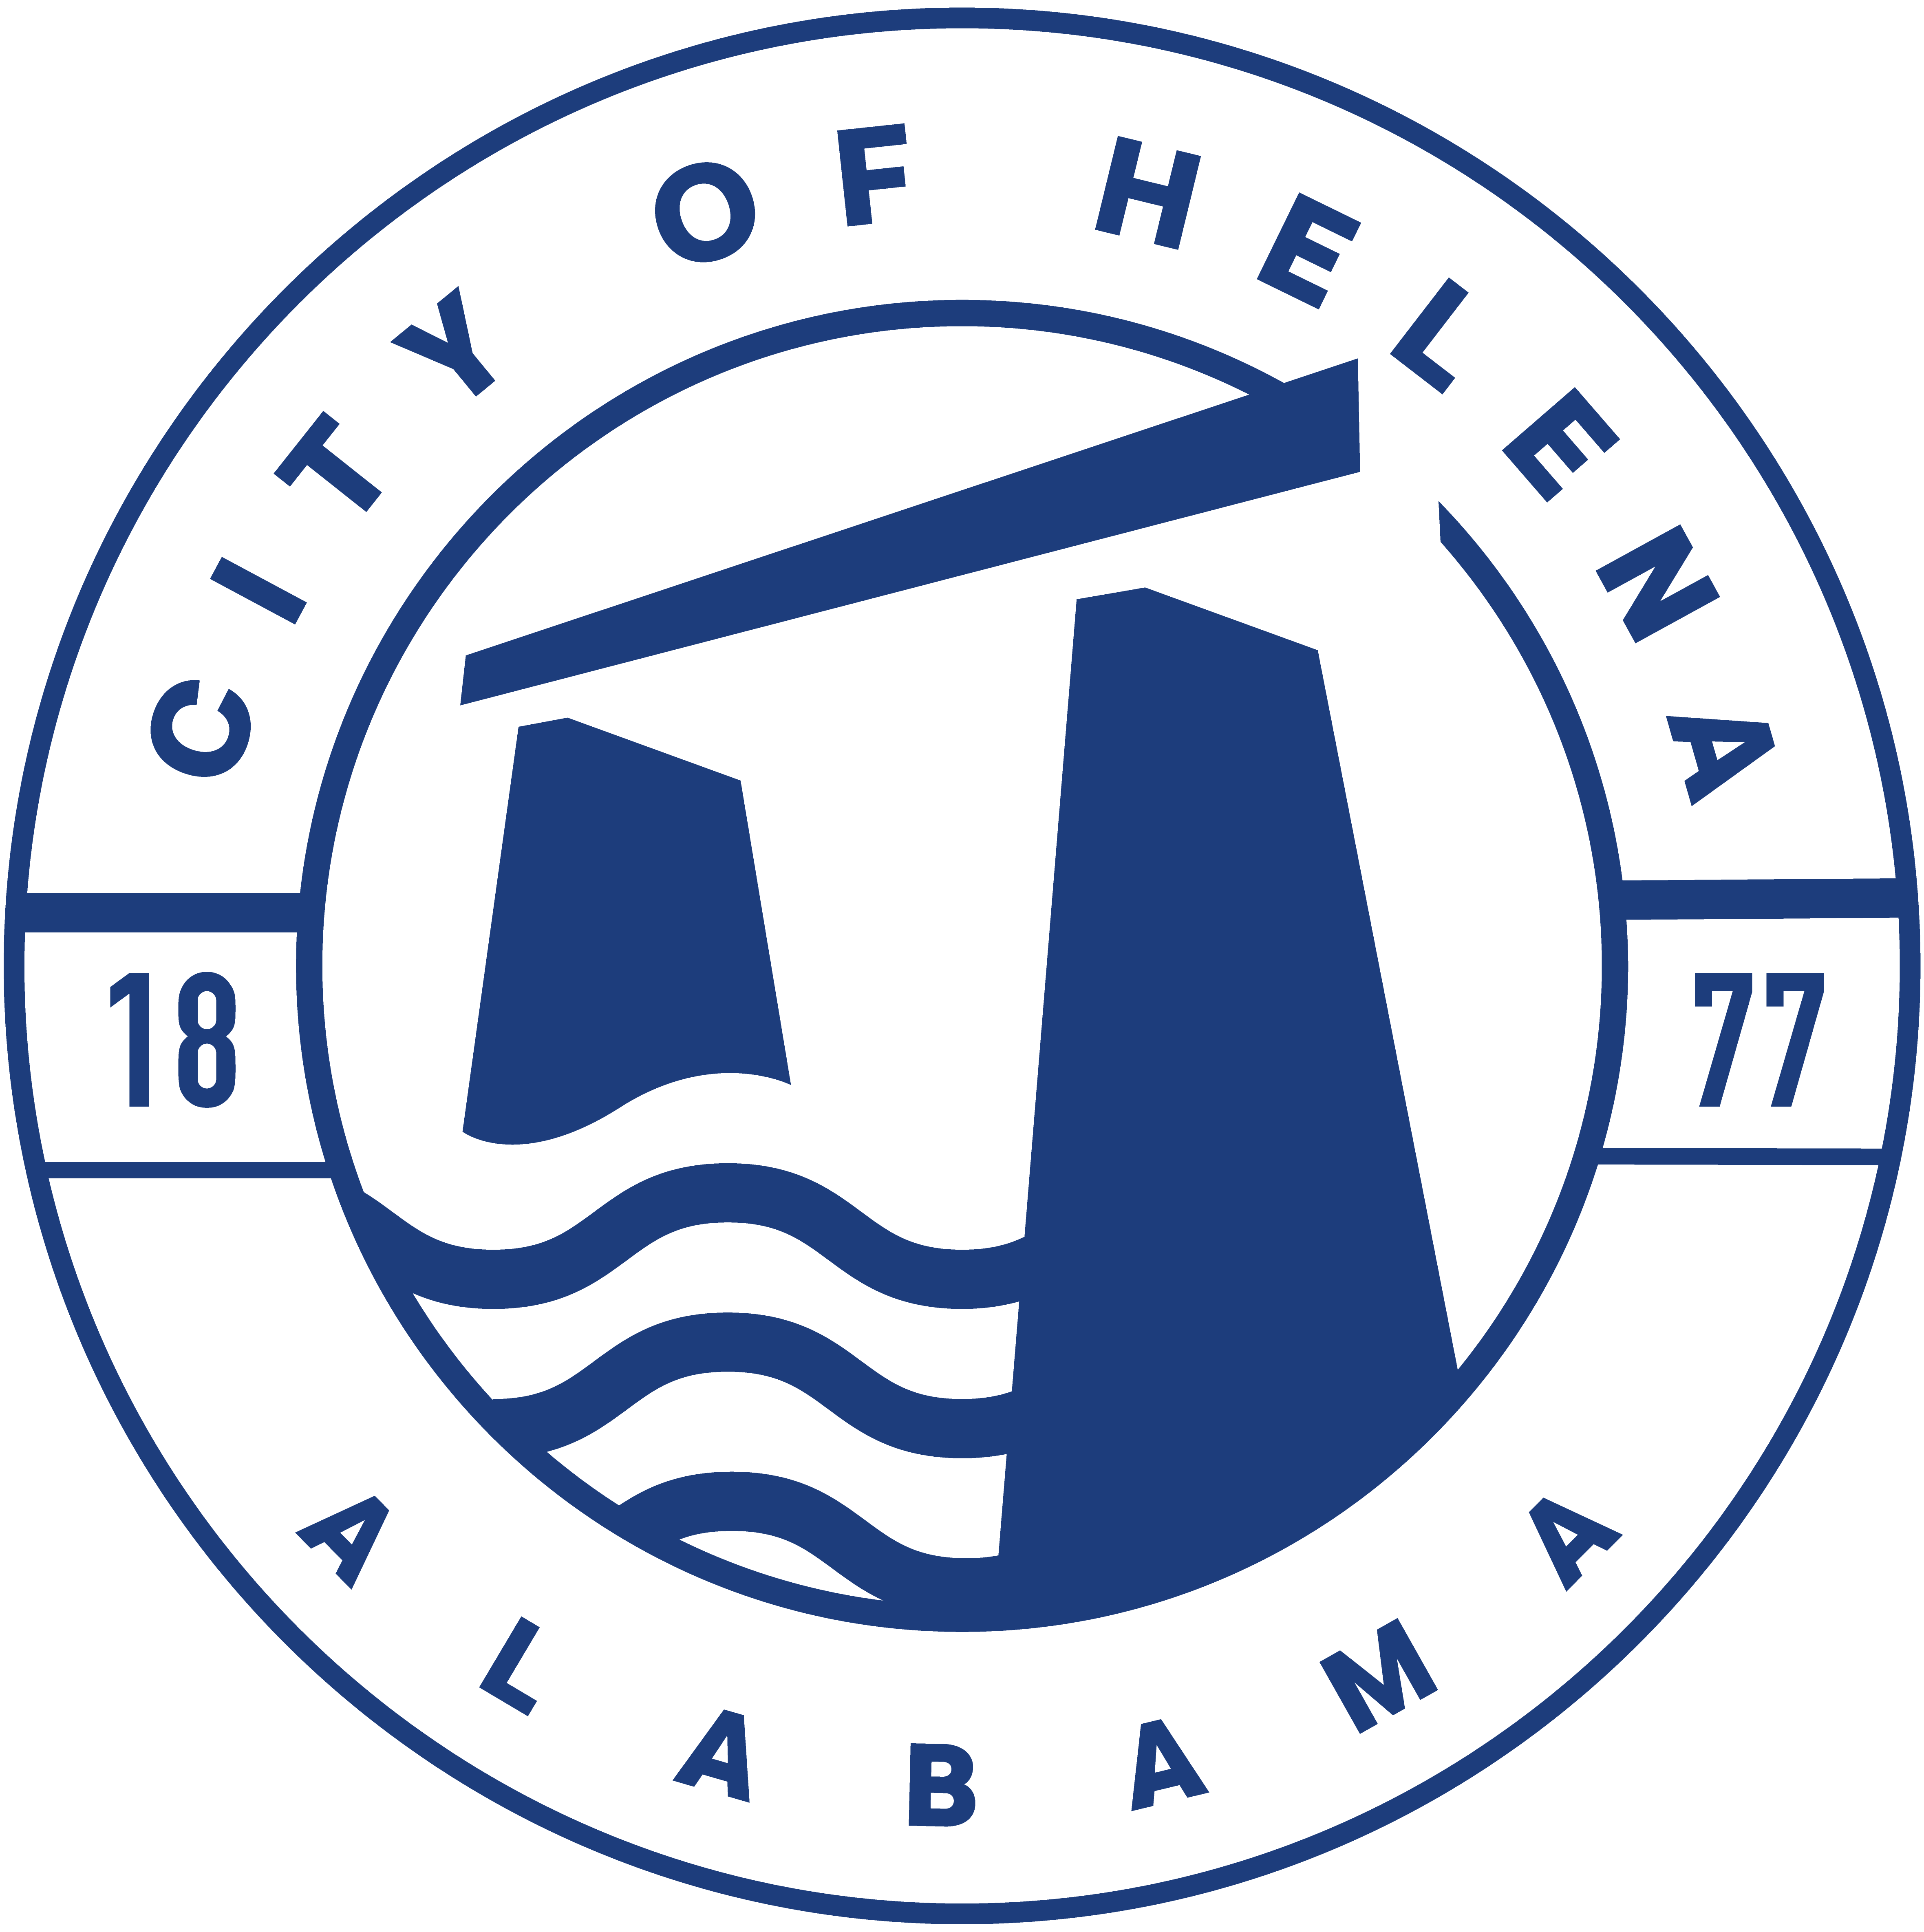
816 Hwy 52 East, Helena AL 35080
City Hall Council Chambers

WORK SESSION MEETING
April 18, 2023

WORK SESSION MEETING AGENDA 5:30pm

- Meeting Called to Order
- Council Roll Call
- DISCUSSION/REVIEW: Ordinance 912-2023-Superseding Ordinance 761-08-Council Procedures
- Adjournment

Proper notice of the posted Agenda for the Pre-Council Work Session and Regular Scheduled Meeting of the Helena City Council was given in advance of such a public meeting and the notice remained posted through the scheduled meeting. By general consent of the Council, agenda items may be added, removed, or considered out of order. Next City Council Meeting Date: Monday, April 24,2023 @ 5:00 P.M. Work Session followed by the Regular Council Meeting 6:00pm.

Updated: 04/13/2023

