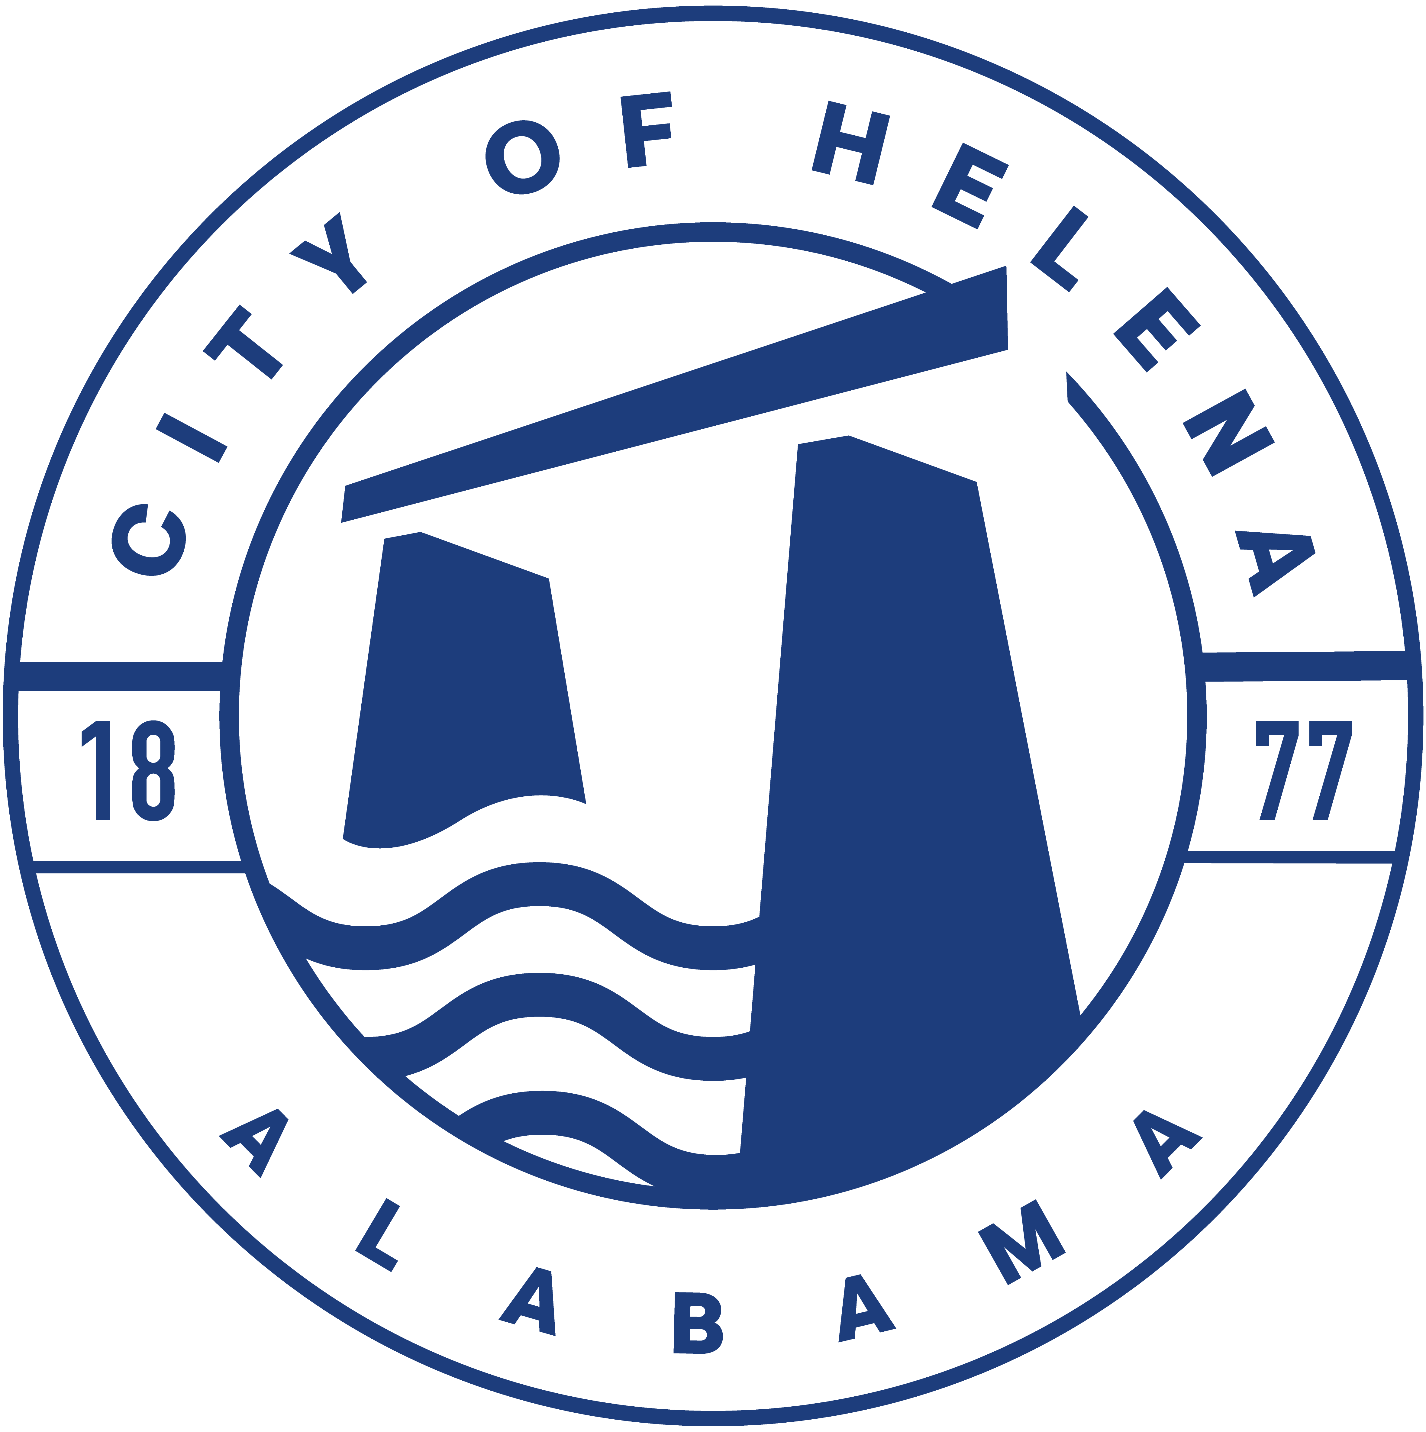
816 Hwy 52 East, Helena AL 35080
City Hall Council Chambers

Helena City Council April 10, 2023
Council Work Session 5pm
- Review of all the 04/10/2023 Agenda Items
  - AP/Bill Payments
  - 3/13/2023 Meeting Minutes Review
- Update from Council Boards and Committee Business
- Mayor’s Update
- Ordinance 912-2023-Superseding Ordinance 761-08-Council Procedures
- Resolution 03132023B- By Laws for Industrial Development Board of the City of Helena
- Budget Amendment of $2,162.48 for public legal notice regarding the State Act for the City of Helena Entertainment District
- Condemnation Process for the following addresses, under Ordinance 517-96, Property Maintenance Code and Existing Building Code/Fire Code: 5240 Roy Drive, 4734 Hollow Lane, 1426 Secretariat Drive, and 3309 Helena Road
- National Fitness Campaign Presentation
- Britney Rhoden-Concerns on location of new city hall site
- Confirmation of the 04/24/2023 Regular Meeting

City Council Meeting Agenda 6pm
- Meeting Called to Order
- Invocation
- Pledge of Allegiance- Eagle Scout Tristan Mitchell
- Council Roll Call
- Presentation of Minutes from 03/13/2023
- Revenue Report and (AP) Bill Payment
- Municipal Operations Report: Mayor J. Brian Puckett
  - Departments: Police, Fire, Library, Parks, Public Works, Inspections, Sanitation, and Utilities
- Proclamation-Proclaiming April 2023 as Autism Awareness Month
- Tag Team Grant Awards for Helena Elementary, Helena Intermediate, Helena Middle and Helena High Schools.
- School Donations for Helena Elementary, Helena Intermediate, Helena Middle and Helena High Schools.
- Recognition of Eagle Scout Tristan Mitchell
- Approve/Deny: Invitation to Bid for Trash/Recycling Services to begin September 1, 2023
- Approve/Deny: 912-2023 Council Procedures- This will supersede Ordinance 761-08
- Approve/Deny: Resolution 03132023B-By Laws for Industrial Development Board of the City of Helena
- Approve/Deny: Budget Amendment of $2,162.48 for public legal notice regarding the State Act for the City of Helena Entertainment District
- Approve/Deny: National Fitness Campaign
- Approve/Deny: To begin Condemnation Process for the following addresses, under Ordinance 517-96, Property Maintenance Code and Existing Building Code/Fire Code: 5240 Roy Drive, 4734 Hollow Lane, 1426 Secretariat Drive, and 3309 Helena Road
- Proclamation-Proclaiming the month of April 2023 as Fair Housing Month
- Council Comments
- Adjournment

Proper notice of the posted Agenda for the Pre-Council Work Session and Regular Scheduled Meeting of the Helena City Council was given in advance of such a public meeting and the notice remained posted through the scheduled meeting. By general consent of the Council, agenda items may be added, removed, or considered out of order. Next City Council Meeting Date: Next Regular Scheduled Meeting will be April 24, 2023 @ 5pm Work Session followed by Regular Meeting at 6:00pm.

Updated: 4/5/2023

