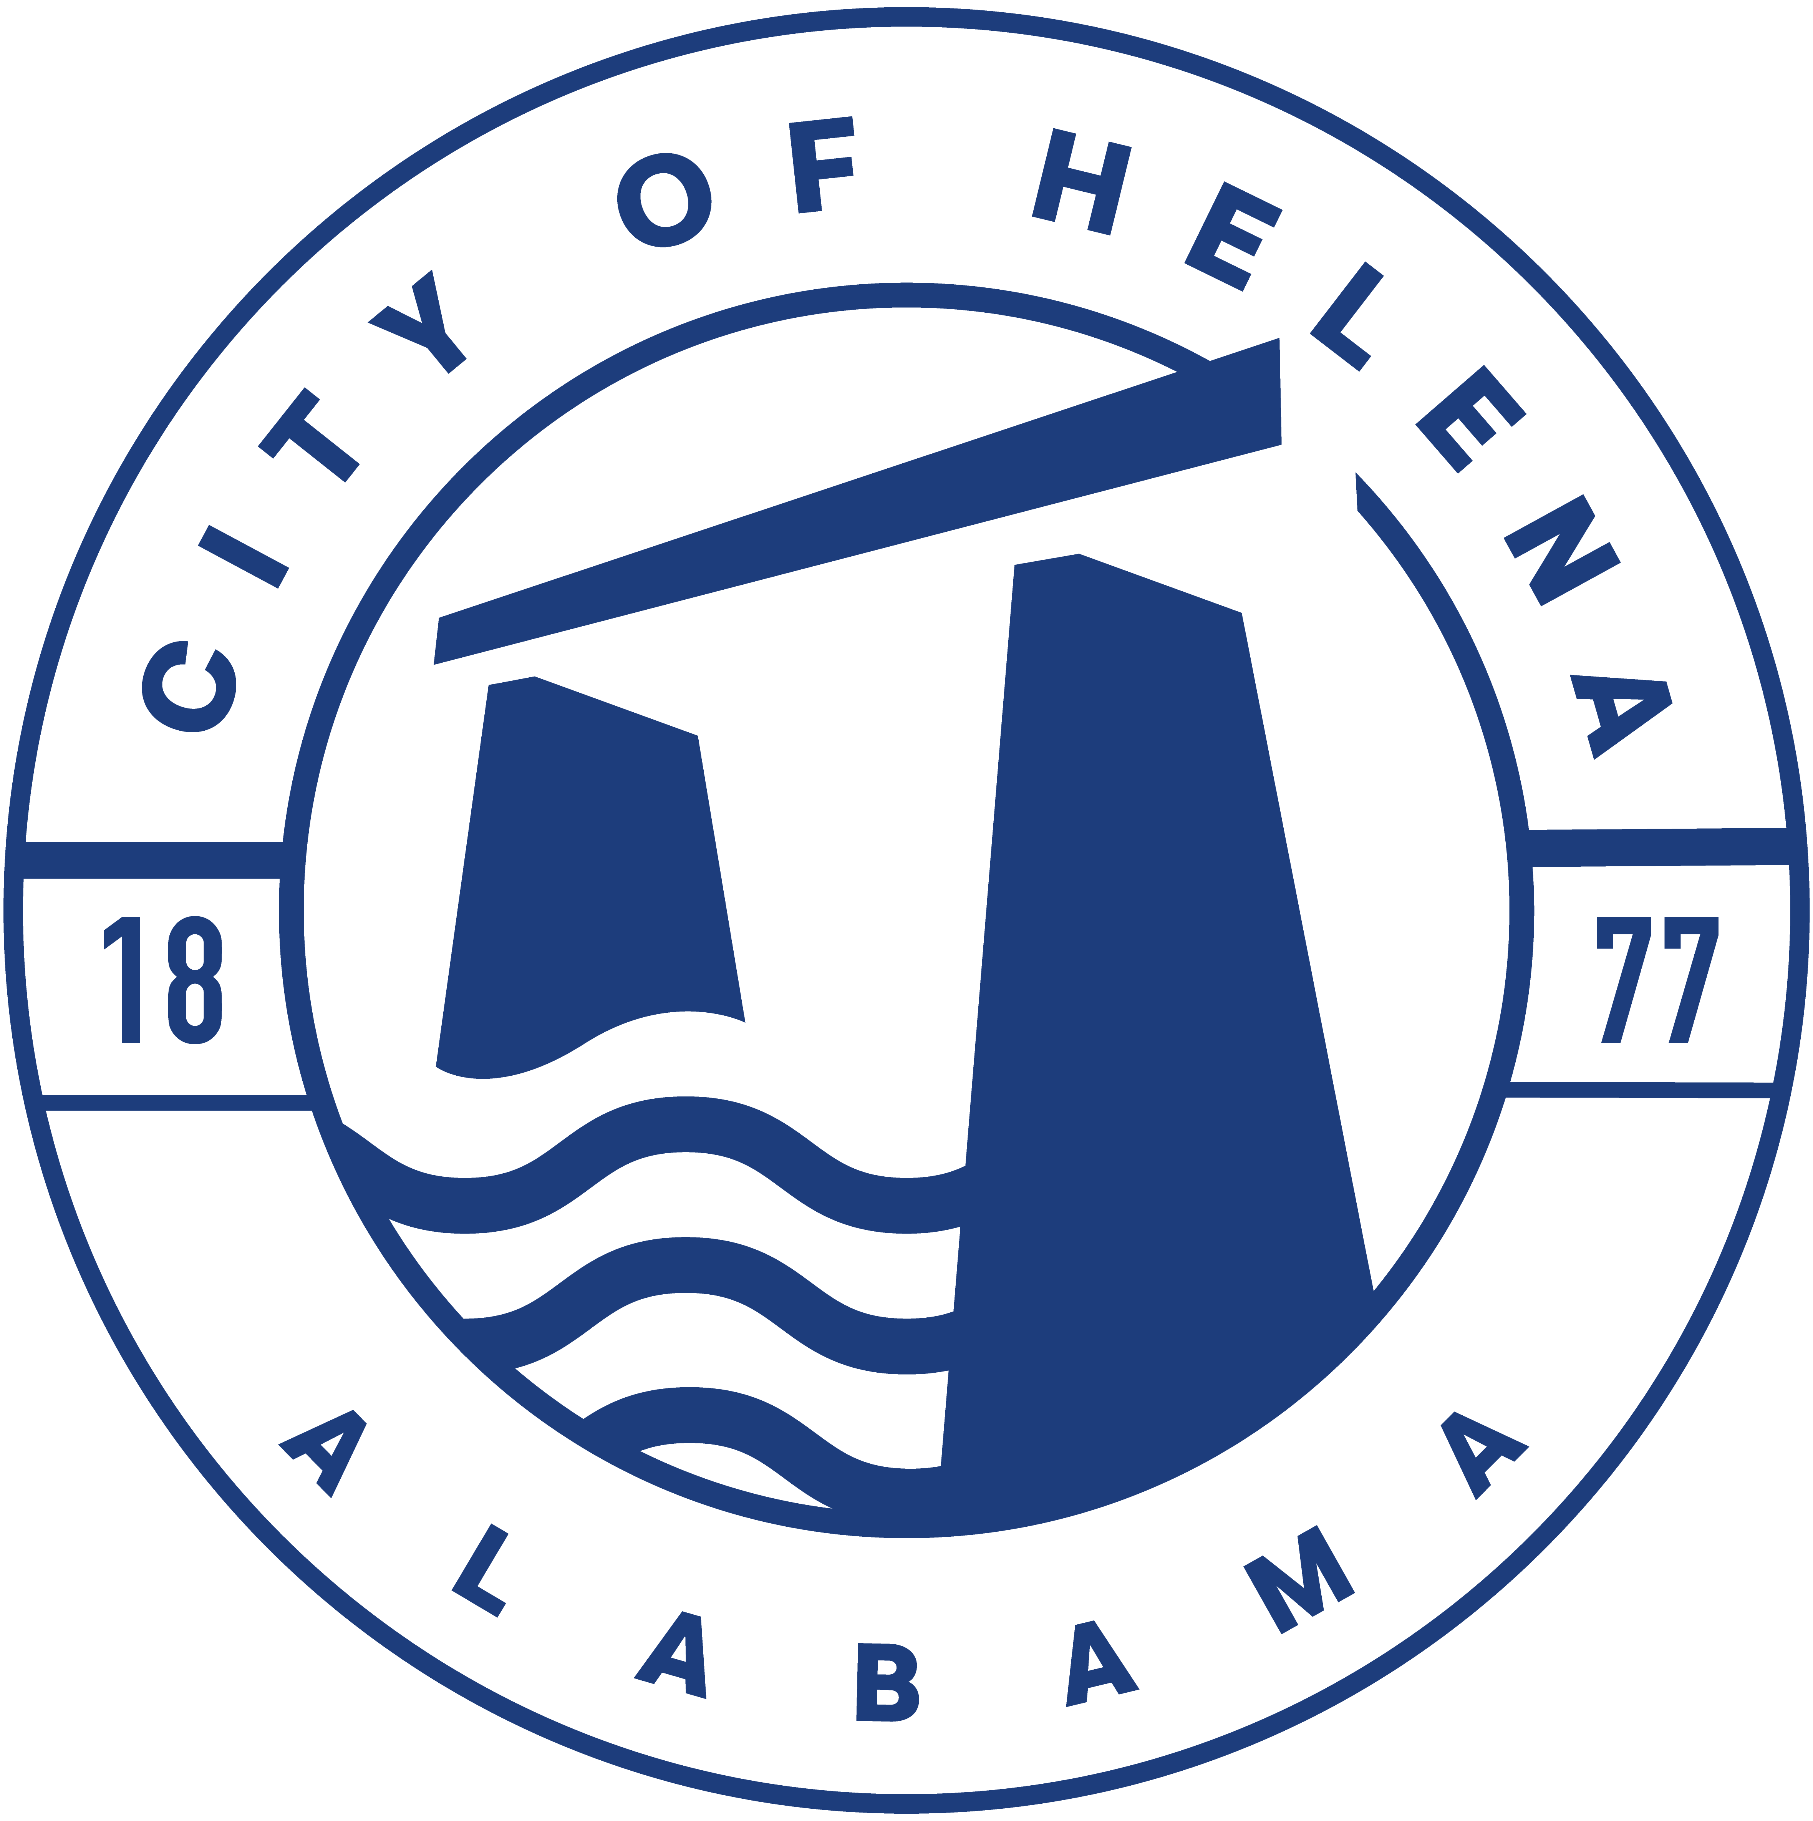
816 Hwy 52 East, Helena AL 35080
City Hall Council Chambers

Helena City Council March 13, 2023
Council Work Session 5pm
- Review of all the 03/11/2023 Agenda Items
  - AP/Bill Payments
  - 2/27/2023 Meeting Minutes Review
- Update from Council Boards and Committee Business
- Mayor’s Update
- Doug Ingram- Community attendance and Council Transparency
- Ordinance 912-2023-Superseding Ordinance 761-08-Council Procedures
- JR Adams-Parks and Recreation
- Confirmation of the 03/27/2023 Regular Meeting

City Council Meeting Agenda 6pm
- Meeting Called to Order
- Invocation
- Pledge of Allegiance
- Council Roll Call
- Presentation of Minutes from 2/27/2023
- Revenue Report and (AP) Bill Payment
- Municipal Operations Report: Mayor J. Brian Puckett
  - Departments: Police, Fire, Library, Parks, Public Works, Inspections, Sanitation, and Utilities
- Approve/Deny: 912-2023 Council Procedures- This will supersede Ordinance 761-08
- Approve/Deny: Resolution 03132023- Dissolution of Helena Economic Development Board with intent of forming the Industrial Development Board of the City of Helena
- Approve/Deny: Resolution 03132023A-A Resolution forming the Industrial Development Board of the City of Helena
- Approve/Deny: Resolution 03132023B-By Laws for Industrial Development of the City of Helena
- Council Comments
- Adjournment

Proper notice of the posted Agenda for the Pre-Council Work Session and Regular Scheduled Meeting of the Helena City Council was given in advance of such public meeting and the notice remained posted through the scheduled meeting. By general consent of the Council, agenda items may be added, removed, or considered out of order. Next City Council Meeting Date: Next Regular Scheduled Meeting will be March 27, 2023 @ 5pm Work Session followed by Regular Meeting at 6:00pm.

Updated: 3/13/2023

