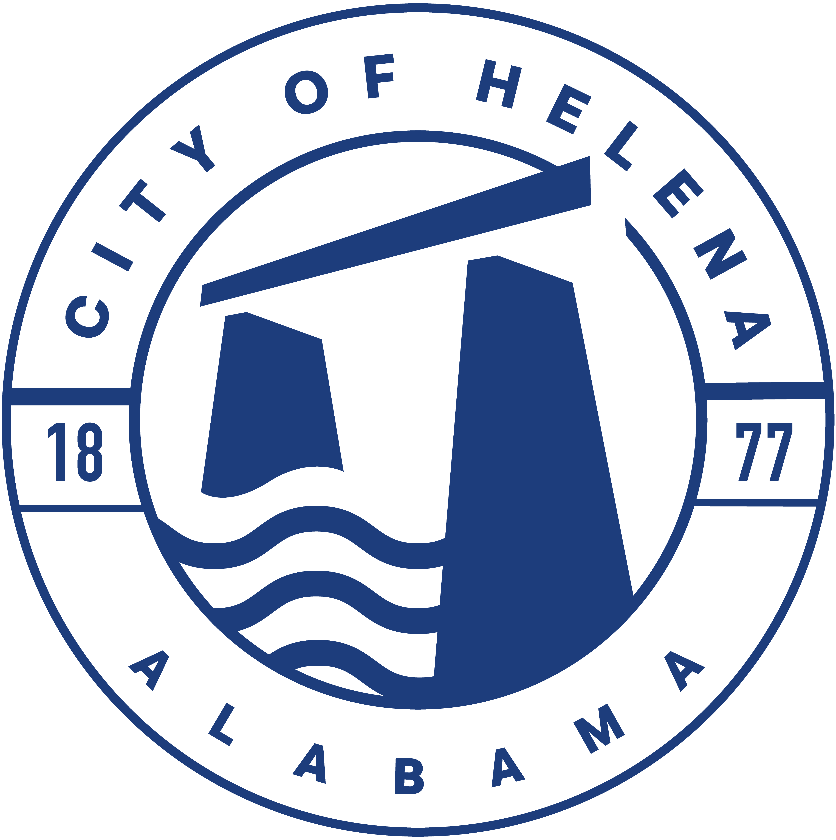
816 Hwy 52 East, Helena AL 35080
City Hall Council Chambers

Helena City Council February 27, 2023
Council Work Session 5pm
- Review of all the 02/27/2023 Agenda Items
  - AP/Bill Payments
  - 2/13/2023 Meeting Minutes Review
- Update from Council Boards and Committee Business
- Mayor’s Update
- Ordinance 912-2023-Superseding Ordinance 761-08-Council Procedures
- Bid Award for Facility Pavement Repairs and Parking Improvements Project
- Concerned Citizens of Rolling Mill Street Petition for Remedies
- Doug Ingram- Community attendance and Council Transparency
- Confirmation of the 03/13/2023 Regular Meeting

City Council Meeting Agenda 6pm
- Meeting Called to Order
- Invocation
- Pledge of Allegiance
- Council Roll Call
- Presentation of Minutes from 2/13/2023
- Revenue Report and (AP) Bill Payment
- Municipal Operations Report: Mayor J. Brian Puckett
  - Departments: Police, Fire, Library, Parks, Public Works, Inspections, Sanitation, and Utilities
- Recognition of Helena High School Track- AHSAA 6A Indoor Track and Field Athletes Top 5 Finishers-2nd Place Shot Put Brooklyn Kelley, 3rd Place Long Jump Walter Womack, 5th Place 800 Meter Run Aspen Warren, 5th Place Boys 4x200 Meter Relay Team Walter Womack, Jeremiah Benson, Jalon Benson, and Brandon Williams
- Recognition of Helena Middle School Student Bryce Newman- 2023 USA Men’s Shooting Alabama State Champion and received an invitation to compete in the Junior Olympics
- Recognition of Helena High School Student Carley Seabrooke-Women’s U18 Smallbore State Champion and earned an automatic qualification to compete in the Smallbore and Air Rifle Divisions of the Junior Olympics
- Approve/Deny: Bid Award for Facility Pavement Repairs and Parking Improvements Project
- Approve/Deny: ABC Board License for Buck Creek Festival
- Approve/Deny: Resolution 02272023 for Mutual Aid with McAdory Fire District
- First Reading: 912-2023 Council Procedures- This will supersede Ordinance 761-08
- Council Comments
- Adjournment

Proper notice of the posted Agenda for the Pre-Council Work Session and Regular Scheduled Meeting of the Helena City Council was given in advance of such public meeting and the notice remained posted through the scheduled meeting. By general consent of the Council, agenda items may be added, removed, or considered out of order. Next City Council Meeting Date: Next Regular Scheduled Meeting will be March 13, 2023 @ 5pm Work Session followed by Regular Meeting at 6:00pm.

Updated: 02/23/2023

