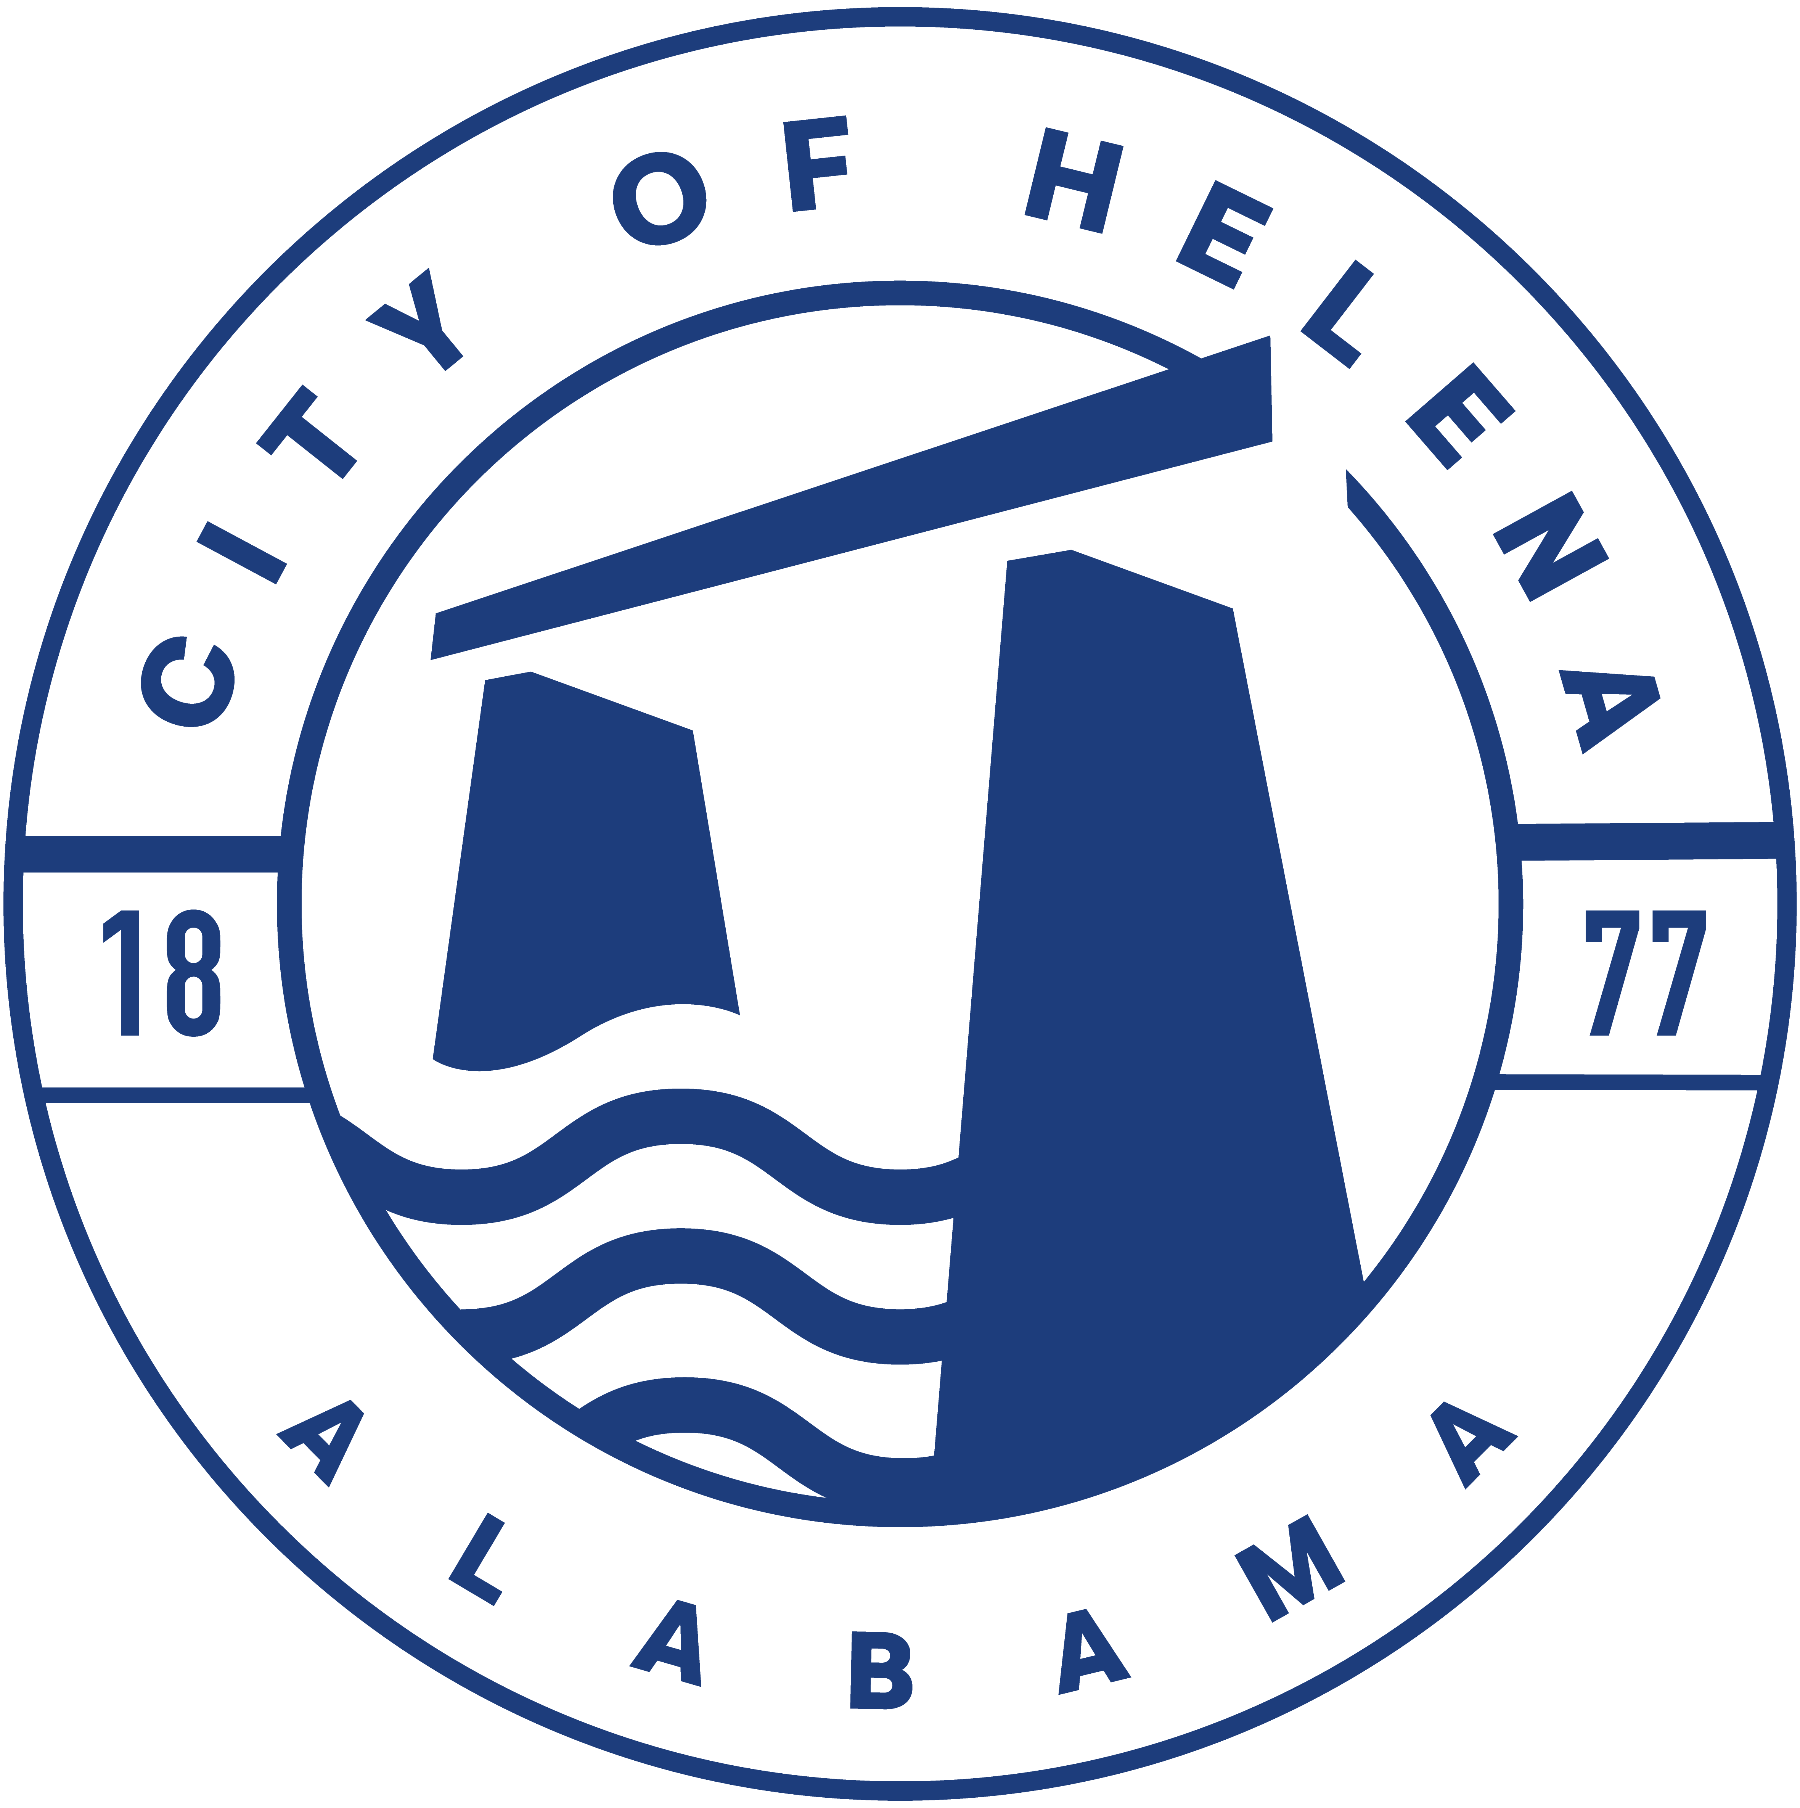
816 Hwy 52 East, Helena AL 35080
City Hall Council Chambers

Helena City Council February 13, 2023
Council Work Session 5pm
- Review of all the 02/13/2023 Agenda Items
  - AP/Bill Payments
  - 1/23/2023 Meeting Minutes Review
- Update from Council Boards and Committee Business
- Ordinance 911-2023-Discussion
- Ordinance 912-2023-Superseding Ordinance 761-08-Council Procedures
- Allowing the Mayor to explore real property.
- Confirmation of the 02/27/2023 Regular Meeting

City Council Meeting Agenda 6pm
- Meeting Called to Order
- Invocation
- Pledge of Allegiance
- Council Roll Call
- Presentation of Minutes from 1/23/2023
- Revenue Report and (AP) Bill Payment
- Municipal Operations Report: Mayor J. Brian Puckett
  - Departments: Police, Fire, Library, Parks, Public Works, Inspections, Sanitation, and Utilities
- Approve/Deny: Ordinance 911-2023 Electric Vehicle Infrastructure Guidelines
- Approve/Deny: Budget Amendment-Purchase of Garbage Truck
- Approve/Deny: Allowing the Mayor to Explore Real Property
- First Reading: 912-2023 Council Procedures- This will supersede Ordinance 761-08
- Council Comments
- Adjournment

Proper notice of the posted Agenda for the Pre-Council Work Session and Regular Scheduled Meeting of the Helena City Council was given in advance of such public meeting and the notice remained posted through the scheduled meeting. By general consent of the Council, agenda items may be added, removed, or considered out of order. Next City Council Meeting Date: Next Regular Scheduled Meeting will be February 27, 2023 @ 5pm Work Session followed by Regular Meeting at 6:00pm.

Updated: 02/09/2023

