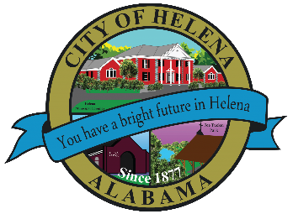
816 Hwy 52 East, Helena AL 35080
City Hall Council Chambers

WORK SESSION MEETING
December 5, 2022

WORK SESSION MEETING AGENDA 5pm

- Meeting Called to Order
- Council Roll Call
- DISCUSSION/REVIEW: Council Applicants for Council Vacancy
- Adjournment

Proper notice of the posted Agenda for the Pre-Council Work Session and Regular Scheduled Meeting of the Helena City Council was given in advance of such public meeting and the notice remained posted through the scheduled meeting. By general consent of the Council, agenda items may be added, removed, or considered out of order. Next City Council Meeting Date: Monday, December 12, 2022 @ 5:00 P.M. Work Session followed by the Regular Council Meeting 6:00pm.

Updated: 11/28/2022

