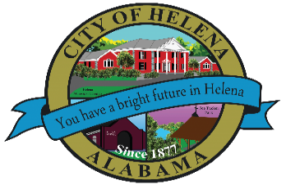
816 Hwy 52 East, Helena AL 35080
City Hall Council Chambers

Helena City Council November 28, 2022
Council Work Session 5pm
- Review of all the 11/28/2022 Agenda Items
  - AP/Bill Payments
  - 11/14/2022 Meeting Minutes Review
- Update from Council Boards and Committee Business
- Discussion of Council President Pro Temp
- Discussion of Golf Carts
- Discussion of Debris Services
- Discussion of Amendments to General Guidelines for Appointed Advisory Boards
- Jessica Smith-Alabama Yard Debris
- Confirmation of the 12/12/2022 Regular Meeting

City Council Meeting Agenda 6pm
- Meeting Called to Order
- Invocation
- Pledge of Allegiance
- Council Roll Call
- Presentation of Minutes from 11/14/2022
- Revenue Report and (AP) Bill Payment
- Municipal Operations Report: Mayor J. Brian Puckett
  - Departments: Police, Fire, Library, Parks, Public Works, Inspections, Sanitation, and Utilities
- Approve/Deny: Ordinance 907-2022A-Annexation-Timothy C. Parker-101 Pleasant Place Bessemer, AL 35022-Parcel ID 12 8 28 0 000 009.003
- Approve/Deny: Ordinance 908-2022- Low Speed Vehicle/Golf Cart Regulations
- Council Comments
- Adjournment

Proper notice of the posted Agenda for the Pre-Council Work Session and Regular Scheduled Meeting of the Helena City Council was given in advance of such public meeting and the notice remained posted through the scheduled meeting. By general consent of the Council, agenda items may be added, removed, or considered out of order. Next City Council Meeting Date: Next Regular Scheduled Meeting will be December 12, 2022 @ 5pm Work Session followed by Regular Meeting at 6:00pm.

Updated: 11/28/2022

***MEETING HAS BEEN CANCELLED DUE TO LACK OF QUORUM. LAURA JOSEPH AND HAROLD WOODMAN ARE UNABLE TO ATTEND. ***

