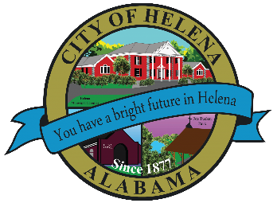
816 Hwy 52 East, Helena AL 35080
City Hall Council Chambers
Helena City Council June 27, 2022
Council Work Session 4:30pm
- Review of all the 06/27/2022 Agenda Items
  - AP/Bill Payments
  - 06/27/2022 Meeting Minutes Review
- Update from Council Boards and Committee Business
- Helena Forward Project Agreement
- Sain and Associates- Pavement Plan Presentation
- Confirmation of the 07/11/2022 Regular Meeting

City Council Meeting Agenda 6pm
- Meeting Called to Order
- Invocation
- Pledge of Allegiance
- Council Roll Call
- Presentation of Minutes from 06/13/2022
- Revenue Report and (AP) Bill Payment
- Municipal Operations Report: Mayor J. Brian Puckett
  - Departments: Police, Fire, Library, Parks, Public Works, Inspections, Sanitation, and Utilities
- Approve/Deny: Second Reading Ordinance 894-2022- On Street Parking Regulations (Replacing Ordinance 431 Amendment)
- Approve/Deny: Purchase Mower Using One Cent Fund and Use Tax up to $57,000.00
- Approve/Deny: Resolution 06272022-Act 2022-229-Retiree Longevity Bonus Legislation-Estimated $13,122.00
- Council Comments
- Adjournment

Proper notice of the posted Agenda for the Pre-Council Work Session and Regular Scheduled Meeting of the Helena City Council was given in advance of such public meeting and the notice remained posted through the scheduled meeting. By general consent of the Council, agenda items may be added, removed, or considered out of order. Next City Council Meeting Date: Next Regular Scheduled Meeting will be July 11, 2022 @ 5pm Work Session followed by Regular Meeting at 6:00pm.

Updated: 06/21/2022

