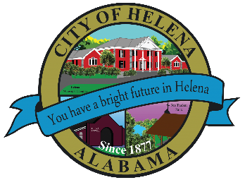
816 Hwy 52 East, Helena AL 35080
City Hall Council Chambers
Helena City Council June 13, 2022
Council Work Session 5:00pm
- Review of all the 06/13/2022 Agenda Items
  - AP/Bill Payments
  - 05/09/2022 Meeting Minutes Review and Special Called Meeting on 05/18/2022
- Update from Council Boards and Committee Business
- Ordinance 894-2022-On Street Parking Regulations (Replacing Ordinance 431 Amendment)
- Confirmation of the 06/27/2022 Regular Meeting

City Council Meeting Agenda 6pm
- Meeting Called to Order
- Invocation
- Pledge of Allegiance
- Council Roll Call
- Presentation of Minutes from 05/09/2022 and Special Called Meeting on 05/18/2022
- Revenue Report and (AP) Bill Payment
- Municipal Operations Report: Mayor J. Brian Puckett
  - Departments: Police, Fire, Library, Parks, Public Works, Inspections, Sanitation, and Utilities
- Recognition of Helena High School Track and Field Outdoor State Track Meet
- Recognition of Helena High School Softball Team for coming in 2nd in State
- Approve/Deny: Resolution 06132022-ALDOT-2022 ATRIP-II Project
- Approve/Deny: Resolution 06132022A-ALDOT- SR-261 and CR-52E- Project # CMAQ-0261(501); CPMS Ref# 100067711: Project# 059-261-005’ CPMS Ref# 100075081
- Approve/Deny: Resolution 20220613-MIS (Municipal Intercept Services) Partnership
- Approve/Deny: Stormwater Bid Process Initiation
- Approve/Deny: Sidewalk Improvement Bid Process Initiation
- Appointment of HOT Board Member JC Harmon
- Approve/Deny: Amendment to HOT Board bylaws
- Approve/Deny: Budget Amendment for -Christmas in Helena Expense $12,802.00
- First Reading Ordinance 894-2022- On Street Parking Regulations (Replacing Ordinance 431 Amendment)
- Approve/Deny: Budget Amendment for Police Car Computers up to $29,000.00
- Council Comments
- Adjournment

Proper notice of the posted Agenda for the Pre-Council Work Session and Regular Scheduled Meeting of the Helena City Council was given in advance of such public meeting and the notice remained posted through the scheduled meeting. By general consent of the Council, agenda items may be added, removed, or considered out of order. Next City Council Meeting Date: Next Regular Scheduled Meeting will be June 27, 2022 @ 5pm Work Session followed by Regular Meeting at 6:00pm.

Updated: 06/13/2022

