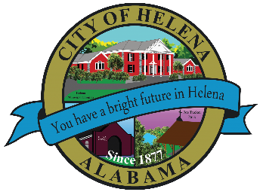
816 Hwy 52 East, Helena AL 35080
City Hall Council Chambers
Helena City Council May 9, 2022
Council Work Session 5:00pm
- Review of the 05/09/2022 Agenda Items
  - AP/Bill Payments
  - 04/25/2022 Meeting Minutes Review
- Update from Council Boards and Committee Business
- Parking Ordinance Discussion
- Discuss Bid on Fence around Cabin at Joe Tucker Park
- Discussion of Appointment of New Planning and Zoning Board Member
- Leigh Hulsey-Council Procedures
- Confirmation of the 06/13/2022 Regular Meeting

City Council Meeting Agenda 6pm
- Meeting Called to Order
- Invocation
- Pledge of Allegiance
- Council Roll Call
- Presentation of Minutes from 04/25/2022
- Revenue Report and (AP) Bill Payment
- Municipal Operations Report: Mayor J. Brian Puckett
  - Departments: Police, Fire, Library, Parks, Public Works, Inspections, Sanitation, and Utilities
- Mayor Puckett-Thank you to Senator April Weaver for attaining a grant for Old Town Live Events
- Alice Lobell-Thank you to House of Representatives Kenneth Paschal for attaining a grant for Helena Teen Council and Helena Senior Citizens Dinner
- Mayor Puckett-Donations to Helena High, Helena Middle, Helena Intermediate and Helena Elementary Schools- $25,000.00 for each school
- Second Reading: Approve/Deny: Parking Ordinance 892-2022
- Appointment of Planning and Zoning Board Member
- Approve/Deny: Bid for Fence around Cabin at Joe Tucker Park
- Approve/Deny: ABC License-Osaka Japanese Sushi Steakhouse-4290 Hwy 52; Suite A-020 Restaurant Retail Liquor
- Dan Dearing-Summer Reading Programs
- Recognition- Helena Teen Council 2022 Seniors
- Recognition- Shelby Chamber Student and Educator of the Year Nominees and Winners
- Phillip Bahakel-Candidate for District Judge
- Jodie Tallie-Candidate for District Judge
- Council Comments
- Adjournment

Proper notice of the posted Agenda for the Pre-Council Work Session and Regular Scheduled Meeting of the Helena City Council was given in advance of such public meeting and the notice remained posted through the scheduled meeting. By general consent of the Council, agenda items may be added, removed, or considered out of order. Next City Council Meeting Date: Next Regular Scheduled Meeting will be June 13, 2022 @ 5pm Work Session followed by Regular Meeting at 6:00pm. No meeting will be held on May 23, 2022, due to Helena High School Graduation and lack of quorum.

Updated: 05/03/2022

