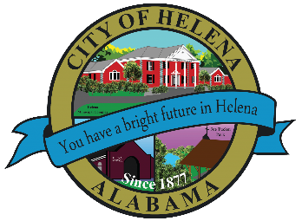
816 Hwy 52 East, Helena AL 35080
City Hall Council Chambers
Helena City Council April 25, 2022
Council Work Session 5:00pm
- Review of the 04/25/2022 Agenda Items
  - AP/Bill Payments
  - 04/11/2022 Meeting Minutes Review
- Update from Council Boards and Committee Business
- Parking Ordinance Discussion
- Zac Parrish-Prezone/Annexation-4915 South Shades Crest Road
- Confirmation of the 05/9/2022 Regular Meeting

City Council Meeting Agenda 6pm
- Meeting Called to Order
- Invocation
- Pledge of Allegiance
- Council Roll Call
- Presentation of Minutes from 04/11/2022
- Revenue Report and (AP) Bill Payment
- Municipal Operations Report: Mayor J. Brian Puckett
  - Departments: Police, Fire, Library, Parks, Public Works, Inspections, Sanitation, and Utilities
- Recognize the Helena Middle School Girls Tennis Team-1st Place in the Southern Conference Championship
- Recognize the Helena Middle School Softball Team for their perfect season and Southern Conference Championship
- Recognize the Helena Middle School Coach Mark Sanders on this 500th win
- Recognize the Helena Middle School Baseball Team for winning Southern Conference Championship
- Approve/Deny: Equipment Building for Park and Recreation- $12,861.00
- Second Reading: Approve/Deny: Sign Ordinance 888-2022
- Second Reading: Approve/Deny: Transportation Impact Fee Ordinance 889-2022
- First Reading: Parking Ordinance 892-2022
- Approve/Deny: Amendment to Ordinance 880-2021
- Approve/Deny: Ordinance 893-2022A-Annexation-4915 South Shades Crest Road-Pending Planning and Zoning Meeting held on April 21, 2022
- Approve/Deny: Rezone Request- Ordinance 891-2022R-4915 South Shades Crest Road-From R1 to R6- Pending Planning and Zoning Meeting held on April 21, 2022
- Approve/Deny: Rezone Request- Ordinance 890-2022R-2698 Helena Road-From R1 to Special District- Pending Planning and Zoning Meeting held on April 21, 2022
- Grady Thornton-Candidate for Alabama Republican Executive Committee, Place 7.
- Bill Dunn-Candidate for District Judge
- Council Comments
- Adjournment

Proper notice of the posted Agenda for the Pre-Council Work Session and Regular Scheduled Meeting of the Helena City Council was given in advance of such public meeting and the notice remained posted through the scheduled meeting. By general consent of the Council, agenda items may be added, removed, or considered out of order. Next City Council Meeting Date: Next Regular Scheduled Meeting will be May 9, 2022 @ 5pm Work Session followed by Regular Meeting at 6:00pm. No meeting will be held on May 23, 2022, due to Helena High School Graduation and lack of quorum.

Updated: 04/21/2022

