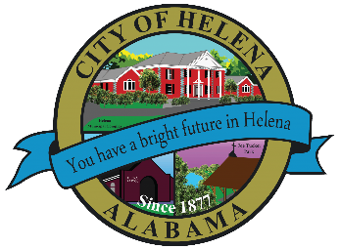
816 Hwy 52 East, Helena, AL 35080
City Hall Council Chambers

Helena Planning and Zoning Commission April 7, 2022

Work Session Meeting Agenda 5:30pm

Meeting Called to Order
Prayer
Pledge of Allegiance
Roll Call
Ordinance Review

Next Meeting
Thursday, April 21, 2022 at 6pm

Posted 04/05/2022

