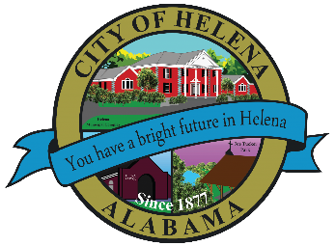
816 Hwy 52 East, Helena AL 35080
City Hall Council Chambers
Helena City Council March 14, 2022
Council Work Session 5:00pm
- Review of the 03/14/2022 Agenda Items
  - AP/Bill Payments
  - 02/28/2022 Meeting Minutes Review
- Update from Council Boards and Committee Business
- Weather Camera Placement
- Board Updates- Farmers Market, Beautification
- Board/Committee Applications Review
- Harold Woodman-Arbor Day Discussion
- Laura Joseph- Dedicated Tree City
- Confirmation of the 04/11/2022 Regular Meeting

City Council Meeting Agenda 6pm
- Meeting Called to Order
- Invocation
- Pledge of Allegiance-Eagle Scouts Brayden and Jarrett LaPore
- Council Roll Call
- Presentation of Minutes from 02/28/2022
- Revenue Report and (AP) Bill Payment
- Municipal Operations Report: Mayor J. Brian Puckett
  - Departments: Police, Fire, Library, Parks, Public Works, Sanitation, and Utilities
- Resolution 03142022-ALDOT Widening of 261 Agreement
- Approve/Deny: HHS School Infrastructure- Using One Cent funds up to $150,000.00
- Recognition of Eagle Scouts Brayden and Jarrett LaPore
- Approve/Deny: Second Reading-Ordinance 886-2022A-Eugene and Emmy Fortinberry-5108 South Shades Crest Road-Parcel ID 4200281000002.002
- Approve/Deny: Second Reading-Ordinance 887-2022A-Eugene Fortinberry-5112 South Shades Crest Road-Parcel ID 4200281000002.007
- Recognition of Helena High School Girls Basketball Team under Coach John Skinner- First basketball team for HHS Basketball to win a playoff game and advance to the Elite 8
- Matt Casey-Candidate for Shelby County District Attorney
- Brian Boatman-Candidate for Shelby County Board of Education, Place 2
- Amber Polk-Candidate for Shelby County Board of Education, Place 1
- Council Comments
- Adjournment

Proper notice of the posted Agenda for the Pre-Council Work Session and Regular Scheduled Meeting of the Helena City Council was given in advance of such public meeting and the notice remained posted through the scheduled meeting. By general consent of the Council, agenda items may be added, removed, or considered out of order. Next City Council Meeting Date: Next Regular Scheduled Meeting will be April 11, 2022 @ 5pm Work Session followed by Regular Meeting at 6:00pm.

Updated: 03/07/2022

