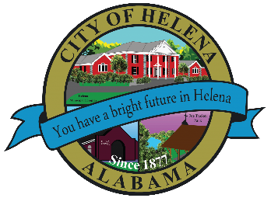
816 Hwy 52 East, Helena AL 35080
City Hall Council Chambers
Helena City Council February 28, 2022
Council Work Session 5:00pm
- Review of the 02/28/2022 Agenda Items
  - AP/Bill Payments
  - 02/14/2022 Meeting Minutes Review
- Update from Council Boards and Committee Business
- Helena High School Infrastructure
- Board Updates- Farmers Market, Beautification, Library, Diversity and Historical Board/Committees
- Gary Stignani- Republic Services- Trash issues and concerns
- Confirmation of the 03/14/2022 Regular Meeting

City Council Meeting Agenda 6pm
- Meeting Called to Order
- Invocation
- Pledge of Allegiance
- Council Roll Call
- Presentation of Minutes from 01/24/2022
- Revenue Report and (AP) Bill Payment
- Municipal Operations Report: Mayor J. Brian Puckett
  - Departments: Police, Fire, Library, Parks, Public Works, Sanitation, and Utilities
- Resolution 02282022-2022 Shelby County Hazard Mitigation Plan Update- Adopting the Shelby County Multi-Jurisdictional, Multi-Hazard Mitigation Plan
- First Reading-Ordinance 886-2020A-Eugene and Emmy Fortinberry-5108 South Shades Crest Road-Parcel ID 4200281000002.002
- First Reading-Ordinance 887-2022A-Eugene Fortinberry-5112 South Shades Crest Road-Parcel ID 4200281000002.007
- Approve/Deny: Buck Creek Festival-ABC License
- Brad Tompkins-Candidate for Alabama House of Representatives, District 15
- Proclamation-Declaration of Read Across Helena Week-February 28-March 4, 2022
- Recognition of Helena High School Track and Field Athlete Brooklyn Kirksey- 2022 AHSAA Pentathlon Runner-up, 6A State Indoor Long Jump Runner Up, and the 6A State Indoor 60m 4th Place.
- Recognition of Helena High School Track and Field Athlete Aspen Warren- 6A State Indoor 800m 5th Place
- Council Comments
- Adjournment

Proper notice of the posted Agenda for the Pre-Council Work Session and Regular Scheduled Meeting of the Helena City Council was given in advance of such public meeting and the notice remained posted through the scheduled meeting. By general consent of the Council, agenda items may be added, removed, or considered out of order. Next City Council Meeting Date: Next Regular Scheduled Meeting will be March 14, 2022 @ 5pm Work Session followed by Regular Meeting at 6:00pm.

Updated: 02/23/2022

