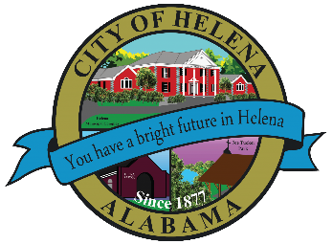
816 Hwy 52 East, Helena AL 35080
City Hall Council Chambers
Helena City Council November 8, 2021
Council Work Session 5:00pm
- Review of the 11/08/2021 Agenda Items
  - AP/Bill Payments
  - 10/25/2021 Meeting Minutes Review
- Update from Council Boards and Committee Business
- RFP City Publications
- Confirmation of the 11/22/2021 Regular Meeting

City Council Meeting Agenda 6pm
- Meeting Called to Order
- Invocation
- Pledge of Allegiance- Girl Scout Troop 28008
- Council Roll Call
- Presentation of Minutes from 11/08/2021
- Revenue Report and (AP) Bill Payment
- Municipal Operations Report: Mayor J. Brian Puckett
  - Departments: Police, Fire, Library, Parks, Public Works, Sanitation, and Utilities
- Presentation of Helena TAG (Teacher Assistant Grants) Team Grants for Helena Elementary, Helena Intermediate, Helena Middle and Helena High School
- Proclamation- Proclaiming November 27, 2021, as Small Business Saturday in Helena
- Approve/Deny: RFP City Publications
- Girl Scout Troop 28008
- Council Comments
- Adjournment

Proper notice of the posted Agenda for the Pre-Council Work Session and Regular Scheduled Meeting of the Helena City Council was given in advance of such public meeting and the notice remained posted through the scheduled meeting. By general consent of the Council, agenda items may be added, removed, or considered out of order. Next City Council Meeting Date: Next Regular Scheduled Meeting will be November 22, 2021 @ 5pm Work Session followed by Regular Meeting at 6:00pm.

Updated: 11/3/2021

