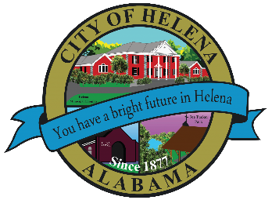
816 Hwy 52 East, Helena AL 35080
City Hall Council Chambers
Helena City Council October 25, 2021
Council Work Session 5:00pm
- Review of the 10/25/2021 Agenda Items
  - AP/Bill Payments
  - 09/27/2021 Meeting Minutes Review
- Update from Council Boards and Committee Business
- Hwy 17/58 Turning Lane
- Storm Water Repairs
- Helena Forward Project
- John Howze-3000 English Oak Circle-Ongoing flooding problem in Twelve Oaks Subdivision
- Confirmation of the 11/8/2021 Regular Meeting

City Council Meeting Agenda 6pm
- Meeting Called to Order
- Invocation
- Pledge of Allegiance
- Council Roll Call
- Presentation of Minutes from 09/27/2021
- Revenue Report and (AP) Bill Payment
- Municipal Operations Report: Mayor J. Brian Puckett
  - Departments: Police, Fire, Library, Parks, Public Works, Sanitation, and Utilities
- Recognition of Helena Fire Department Promotions
- Helena Middle School Principal Dr. Matthew Epps
- Appointment of City Prosecutor Charles Miller
- Proclamation-Proclaiming November as being Hospice Awareness Month
- Proclamation-Proclaiming November as being City of Helena Lung Cancer Month
- Harold Woodman-Recognize October 27th as Annual National Senior Health and Fitness Day and Dave Purell for his efforts to promote physical fitness and winning the 2021 NPC Masters National Bodybuilding Championship in the over 70 Division
- Girl Scout Troop 30080-Recycling Presentation
- Approve/Deny: Harris Doyle-Riverwood Modification to Master Plan
- Approve/Deny: Hwy 17/58 Turning Lane up to $250,000.00 using Rebuild Act/4Cent Funds
- Approve/Deny: Storm Water Repairs using ARPA Funds
- Approve/Deny: Resolution 10252021-Mayor Puckett to enter negotiations with US Steel on Helena Forward Project
- Council Comments
- Adjournment

Proper notice of the posted Agenda for the Pre-Council Work Session and Regular Scheduled Meeting of the Helena City Council was given in advance of such public meeting and the notice remained posted through the scheduled meeting. By general consent of the Council, agenda items may be added, removed, or considered out of order. Next City Council Meeting Date: Next Regular Scheduled Meeting will be November 8, 2021 @ 5pm Work Session followed by Regular Meeting at 6:00pm.

Updated: 10/21/2021

