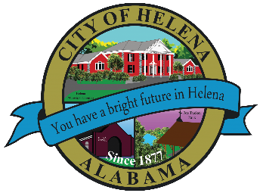
816 Hwy 52 East, Helena AL 35080
City Hall Council Chambers
Helena City Council September 27, 2021
Council Work Session 5:00pm
- Review of the 09/27/2021 Agenda Items
  - AP/Bill Payments
  - 09/13/2021 Meeting Minutes Review
- Update from Council Boards and Committee Business
- Resolution 09272021-Request for Attorney General Opinion
- Resolution 09272021A-Release of K9 Sanczo
- Budget Amendment of $32,000.00 for a Sensory Trailer
- Confirmation of the 10/25/2021 Regular Meeting

City Council Meeting Agenda 6pm
- Meeting Called to Order
- Invocation
- Pledge of Allegiance
- Council Roll Call
- Presentation of Minutes from 08/23/2021
- Revenue Report and (AP) Bill Payment
- Municipal Operations Report: Mayor J. Brian Puckett
  - Departments: Police, Fire, Library, Parks, Public Works, Sanitation, and Utilities
- Proclamation-Kenneth Paschal- Proclaiming September 27, 2021, as Family Day and Proclaiming September 26 through October 2, 2021 as Family Week
- Proclamation-Proclaiming October 1 as Down Syndrome Day
- Proclamation-Proclaiming September as Gynecologic Cancer Awareness Month
- Resolution 09272021-Request Attorney General Opinion
- Resolution 09272021A-Release of K-9 Sanczo
- Leigh Hulsey-Budget Amendment of $32,000.00 for a Sensory Trailer
- Council Comments
- Adjournment

Proper notice of the posted Agenda for the Pre-Council Work Session and Regular Scheduled Meeting of the Helena City Council was given in advance of such public meeting and the notice remained posted through the scheduled meeting. By general consent of the Council, agenda items may be added, removed, or considered out of order. Next City Council Meeting Date: Next Regular Scheduled Meeting will be October 25, 2021 @ 5pm Work Session followed by Regular Meeting at 6:00pm.

Updated: 09/22/2021

