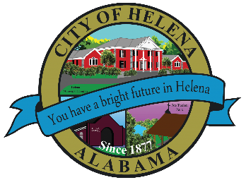
816 Hwy 52 East, Helena AL 35080
City Hall Council Chambers
Helena City Council September 13, 2021
Council Work Session 4:00pm
- Review of the 09/13/2021 Agenda Items
  - AP/Bill Payments
  - 08/23/2021 Meeting Minutes Review
- Update from Council Boards and Committee Business
- FYE 2022 Budget Review
- Confirmation of the 09/27/2021 Regular Meeting

City Council Meeting Agenda 6pm
- Meeting Called to Order
- Invocation
- Pledge of Allegiance
- Council Roll Call
- Presentation of Minutes from 08/23/2021
- Revenue Report and (AP) Bill Payment
- Municipal Operations Report: Mayor J. Brian Puckett
  - Departments: Police, Fire, Library, Parks, Public Works, Sanitation, and Utilities
- Approve/Deny: Resolution 09132021-FYE 2022 General Fund Budget
- Resolution 09132021A-Resolution Indicating the Holidays to be Observed by City Employees for the FYE 2022
- Approve/Deny: Buck Creek Festival-ABC License 150- Special Retail License for Special Event to be held on September 24-25, 2021
- Approve/Deny: Resolution 09132021B- RPI ONE-HELENA- Dedication of Right of Way
- Approve/Deny: Helena Library Budget Amendment Emergency Repair for Building Maintenance
- Approve/Deny: Rezone Request- 2698 Helena Road-R-1 Single Family Residential District to Special District for General Business District Use (Unanimous P&Z Favorable with conditions)
- Council Comments
- Adjournment

Proper notice of the posted Agenda for the Pre-Council Work Session and Regular Scheduled Meeting of the Helena City Council was given in advance of such public meeting and the notice remained posted through the scheduled meeting. By general consent of the Council, agenda items may be added, removed, or considered out of order. Next City Council Meeting Date: Next Regular Scheduled Meeting will be September 27, 2021 @ 5pm Work Session followed by Regular Meeting at 6:00pm.

Updated: 09/13/2021

