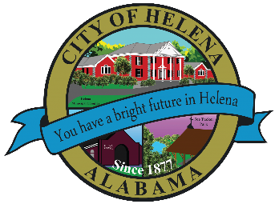
816 Hwy 52 East, Helena AL 35080
City Hall Council Chambers
Helena City Council August 23, 2021
Council Work Session 4:30pm
- Review of the 08/23/2021 Agenda Items
  - AP/Bill Payments
  - 08/09/2021 Meeting Minutes Review
- Update from Council Boards and Committee Business
- Harold Woodman-Forestry update for Helena Amphitheater
- FYE 2022 Budget Review
- Ordinance Amending 734-07, Section 22- To create a new business license type to cover short term rental
- Ordinance Imposing a Lodging Tax on Short Term Rentals
- Ordinance Amending the Zoning Ordinance to provide for Short Term Rental
- Confirmation of the 09/13/2021 Regular Meeting

City Council Meeting Agenda 6pm
- Meeting Called to Order
- Invocation
- Pledge of Allegiance
- Council Roll Call
- Presentation of Minutes from 08/09/2021
- Revenue Report and (AP) Bill Payment
- Municipal Operations Report: Mayor J. Brian Puckett
  - Departments: Police, Fire, Library, Parks, Public Works, Sanitation, and Utilities
- Approve/Deny: Public Works Department Purchase of Street Sweeper using 4/7 cent gas funds- $25,300.00
- Approve/Deny: Public Works Department Purchase of Bucket Truck using 4/7 cent gas funds- $80,000.00
- Second Reading: Approve/Deny: Ordinance Amending 734-07, Section 22- To create a new business license type to cover short term rental
- Second Reading: Approve/Deny: Ordinance Imposing a Lodging Tax on Short Term Rentals
- Second Reading: Approve/Deny: Ordinance Amending the Zoning Ordinance to provide for Short Term Rental
- Repeal of Ordinance 877-2020
- Council Comments
- Adjournment

Proper notice of the posted Agenda for the Pre-Council Work Session and Regular Scheduled Meeting of the Helena City Council was given in advance of such public meeting and the notice remained posted through the scheduled meeting. By general consent of the Council, agenda items may be added, removed, or considered out of order. Next City Council Meeting Date: Next Regular Scheduled Meeting will be September 13, 2021 @ 5pm Work Session followed by Regular Meeting at 6:00pm.
Updated: 08/17/2021

