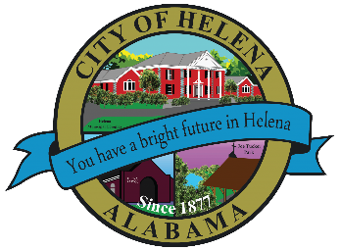
816 Hwy 52 East, Helena AL 35080
City Hall Council Chambers
Helena City Council July 12, 2021
Council Work Session 5pm
Review of the 07/12/2021 Agenda Items
- AP/Bill Payments
- 06/28/2021 Meeting Minutes Review
Update from Council Boards and Committee Business
Short Term Rental’s
Amphitheater Upgrades
Harold Woodman-Way Marker Signs
Harold Woodman-Apple Study Pelham Helena Trail Connector
Laura Nixon-Dedicated space to hold Club of Society of Women Engineers
Alan Phillips, Director of Alabama American Legion Baseball-Sponsorship of the baseball tournament being held in Pelham and Helena and Alabaster.
Confirmation of the 07/26/2021 Regular Meeting Agenda

City Council Meeting Agenda 6pm
Meeting Called to Order
Invocation
Pledge of Allegiance
Council Roll Call
Presentation of Minutes from 06/28/2021
Revenue Report and (AP) Bill Payment
Municipal Operations Report: Mayor J. Brian Puckett
- Departments: Police, Fire, Library, Parks, Streets, Sanitation, and Utilities
Chief Flynn-Recognition of Officer Browning
Approve/Deny: Resolution 07122021-Authorizing Police Officer Outside Employment
Approve/Deny: Fogger Purchase up to $14,000.00-Use Tax Funds
Approve/Deny: Upgrades to Helena Amphitheater-Bollards Purchase and Upgraded Power
Approve/Deny: Ordinance Amending 734-07, Section 22- To create a new business license type to cover short term rental
Approve/Deny: Ordinance Imposing a Lodging Tax on Short Term Rentals
Approve/Deny: Ordinance Amending the Zoning Ordinance to provide for Short Term Rental
Approve/Deny: Ordinance- Helena FEMA Flood Damage Prevention
Approve/Deny: Apple StudyPelham-Helena Connector Trail Connector Study Feasibility up to $6,000.00
Approve/Deny: Request for dedicated space to hold Club of Society of Women Engineers
Council Comments
Adjournment

Proper notice of the posted Agenda for the Pre-Council Work Session and Regular Scheduled Meeting of the Helena City Council was given in advance of such public meeting and the notice remained posted through the scheduled meeting. By general consent of the Council, agenda items may be added, removed, or considered out of order. Next City Council Meeting Date: Next Regular Scheduled Meeting will be July 26, 2021 @ 5pm Work Session followed by Regular Meeting at 6:00pm.

Updated: 07/12/2021

