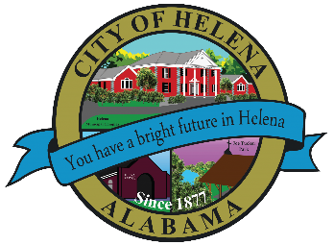
816 Hwy 52 East, Helena AL 35080
City Hall Council Chambers
Helena City Council June 14, 2021
Council Work Session 5:30pm
Review of the 06/14/2021 Agenda Items
- AP/Bill Payments
- 05/24/2021 Meeting Minutes Review
Update from Council Boards and Committee Business
Applicant Review of Helena Diversity and Inclusion Board
Discussion of Street Paving and Patching 2021- Bid ended on 06/08/2021.
Discussion of Budget Amendment for Senior Citizens Programs up to $1,000.00
Confirmation of the 06/28/2021 Regular Meeting Agenda

City Council Meeting Agenda 6pm
Meeting Called to Order
Invocation
Pledge of Allegiance
Council Roll Call
Presentation of Minutes from 05/24/2021
Revenue Report and (AP) Bill Payment
Municipal Operations Report: Mayor J. Brian Puckett
- Departments: Police, Fire, Library, Parks, Streets, Sanitation, and Utilities
Approve/Deny-Street Paving and Patching 2021- Bid ended on 06/08/2021.
Approve/Deny-Budget Amendment for Senior Citizens Programs up to $1,000.00.
Council Comments
Adjournment

Proper notice of the posted Agenda for the Pre-Council Work Session and Regular Scheduled Meeting of the Helena City Council was given in advance of such public meeting and the notice remained posted through the scheduled meeting. By general consent of the Council, agenda items may be added, removed, or considered out of order. Next City Council Meeting Date: Next Regular Scheduled Meeting will be June 28, 2021 @ 5pm Work Session followed by Regular Meeting at 6:00pm.

Updated: 06/09/2021

