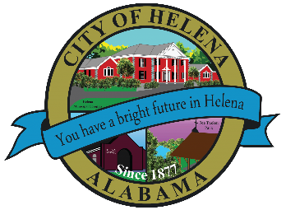
816 Hwy 52 East, Helena AL 35080
City Hall Council Chambers
Helena City Council May 24, 2021
Council Work Session 5pm
Review of the 05/24/2021 Agenda Items
- AP/Bill Payments
- 05/10/2021 Meeting Minutes Review
Update from Council Boards and Committee Business
Approve/Deny-Alabama Power LED Conversation-Pending documentation
Confirmation of the 06/14/2021 Regular Meeting Agenda

City Council Meeting Agenda 6pm
Meeting Called to Order
Invocation
Pledge of Allegiance
Council Roll Call
Presentation of Minutes from 05/10/2021
Revenue Report and (AP) Bill Payment
Municipal Operations Report: Mayor J. Brian Puckett
- Departments: Police, Fire, Library, Parks, Streets, Sanitation, and Utilities
Recognition of Helena High School Track and Field Athlete Brady Barton- AHSAA State Meet -2nd Place meet in both the 800 and 1600.
Recognition of Helena High School Track and Field Athletes for 3rd Place in AHSAA State Meet in 4 x 100- Kya Gardner, Tori North, Brooklyn Kirksey and Lamaria Bennett
Recognition of 1st Place Decathlon State Champion Helena High School Track and Field Athlete Damien Hines.
Approve/Deny-Budget Amendment for up to $32,000.00 for Inspections Vehicle.
Approve/Deny- Bid for Paving City Streets
Approve/Deny-Alabama Power LED Conversation
Approve/Deny-Dedication of Streets- Creekview Phase 2 (Pending Planning and Zoning approval on May 20, 2021 meeting)
Dan Dearing-Summer Reading Programs
Council Comments
Adjournment

Proper notice of the posted Agenda for the Pre-Council Work Session and Regular Scheduled Meeting of the Helena City Council was given in advance of such public meeting and the notice remained posted through the scheduled meeting. By general consent of the Council, agenda items may be added, removed, or considered out of order. Next City Council Meeting Date: Next Regular Scheduled Meeting will be June 14, 2021 @ 5pm Work Session followed by Regular Meeting at 6:00pm.

Updated: 05/18/2021

