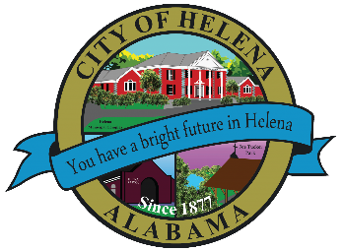
816 Hwy 52 East, Helena AL 35080
City Hall Council Chambers
Helena City Council May 10, 2021
Council Work Session 5pm
Review of the 05/10/2021 Agenda Items
- AP/Bill Payments
- 04/26/2021 Meeting Minutes Review
Update from Council Boards and Committee Business
Jay Elliott-Usage of Joe Tucker Park for the Boy Scout Fishing Rodeo
Harold Woodman-Repair/Replace of storage unit at Helena Amphitheater.
Alice Lobell- Helena Teen Council Fieldtrip up to $2,000.00
City of Helena Audit FYE 2020
Confirmation of the 05/24/2021 Regular Meeting Agenda

City Council Meeting Agenda 6pm
Meeting Called to Order
Invocation
Pledge of Allegiance
Council Roll Call
Presentation of Minutes from 04/26/2021
Revenue Report and (AP) Bill Payment
Municipal Operations Report: Mayor J. Brian Puckett
- Departments: Police, Fire, Library, Parks, Streets, Sanitation, and Utilities
Resolution 05102021-Proclaiming May 2021 as Mental Health Month in the City of Helena
Second Reading-Ordinance Amending Annexation of the Zoning Ordinance-Article V, Section 4
Amendment
Approve/Deny-City of Helena FYE 2020 Audit
Approve/Deny-Jay Elliott-Usage of Joe Tucker Park for the Boy Scout Fishing Rodeo
Approve/Deny- Repair/Replace of storage unit at Helena Amphitheater.
Approve/Deny- Helena Teen Council Fieldtrip up to $2,000.00
Council Comments
Adjournment

Proper notice of the posted Agenda for the Pre-Council Work Session and Regular Scheduled Meeting of the Helena City Council was given in advance of such public meeting and the notice remained posted through the scheduled meeting. By general consent of the Council, agenda items may be added, removed, or considered out of order. Next City Council Meeting Date: Next Regular Scheduled Meeting will be May 24, 2021 @ 5pm Work Session followed by Regular Meeting at 6:00pm.

Updated: 05/05/2021

