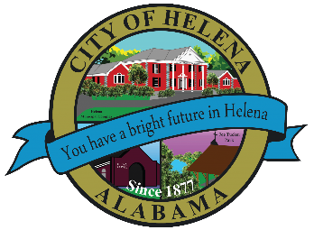
816 Hwy 52 East, Helena AL 35080
City Hall Council Chambers
Helena City Council April 26, 2021

Council Work Session 5pm
Review of the 04/26/2021 Agenda Items
- AP/Bill Payments
- 04/12/2021 Meeting Minutes Review
Update from Council Boards and Committee Business
Laura Joseph-Discussion of IDEA Committee Bylaws
Ronda Cannon-1 Environs Parkway-Approval of Usage
Confirmation of the 05/10/2021 Regular Meeting Agenda

City Council Meeting Agenda 6pm
Meeting Called to Order
Invocation
Pledge of Allegiance
Council Roll Call
Presentation of Minutes from 04/12/2021
Revenue Report and (AP) Bill Payment
Municipal Operations Report: Mayor J. Brian Puckett
- Departments: Police, Fire, Library, Parks, Streets, Sanitation, and Utilities
Proclamation-Helena High School National English Society Library Donation Recognition
Mayor Puckett-Teachers Assistance Grant “TAG” Team Grant Awards
Mayor Puckett-Proclamation-Proclaiming May 3-7, 2021 as National Teacher’s Appreciation Week
Mayor Puckett-Donations to Helena High, Helena Middle, Helena Intermediate and Helena Elementary Schools-$25,000.00 for each school
Second Reading Ordinance 881-2021- Adoption of International Code and Local Fees
Second Reading Amendment to Entertainment District Ordinance 877-2020
First Reading-Ordinance Amending Annexation of the Zoning Ordinance-Article V, Section 4 Amendment
Approval/Denial-Budget Amendment (WFA on Budget) of $2,665.00 for Caboose Lettering (remove and replace)
Approval/Denial-Inclusion, Diversity, Equality & Awareness (IDEA) Committee Bylaws
Approval/Denial-Ronda Cannon-1 Environs Parkway-Approval of Usage
Council Comments
Adjournment

Proper notice of the posted Agenda for the Pre-Council Work Session and Regular Scheduled Meeting of the Helena City Council was given in advance of such public meeting and the notice remained posted through the scheduled meeting. By general consent of the Council, agenda items may be added, removed, or considered out of order. Next City Council Meeting Date: Next Regular Scheduled Meeting will be April 26, 2021 @ 5pm Work Session followed by Regular Meeting at 6:00pm.

Updated: 04/20/2021

