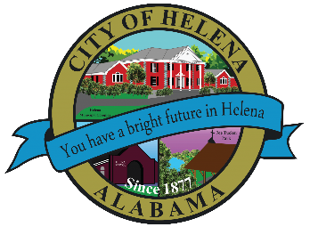
816 Hwy 52 East, Helena AL 35080
City Hall Council Chambers
Helena City Council April 12, 2021

Council Work Session 5pm
Review of the 03/08/2021 Agenda Items
- AP/Bill Payments
- 03/08/2021 Meeting Minutes Review
Update from Council Boards and Committee Business
Riverwoods-Modification from Master Plan-Proposed Commercial to Residential
Chris VanCleave-Discussion of Proximity Park Proposal
Harold Woodman-Greenway Project Payment
Laura Joseph-Discussion of Amendments to the Entertainment District Ordinance
Confirmation of the 04/26/2021 Regular Meeting Agenda

City Council Meeting Agenda 6pm

Meeting Called to Order
Invocation
Pledge of Allegiance
Council Roll Call
Presentation of Minutes from 03/08/2021
Revenue Report and (AP) Bill Payment
Municipal Operations Report: Mayor J. Brian Puckett
- Departments: Police, Fire, Library, Streets, Sanitation, and Utilities
Proclamation-Proclaiming Proclaiming April 2021 as Autism Awareness Month
Proclamation-Proclaiming April 2021 as National Child Abuse Prevention Month in Shelby County Alabama
Resolution 04122021-Resolution to Declare April 17th as Rebecca Luker Day in Helena, AL
Harold Woodman-Approval/Denial-Greenway Project Payment- Use Tax Funds
Riverwoods Modification from Master Plan-Proposed Commercial to Residential-Planning and Zoning meeting on 03/18/2021- tie vote
First Reading Ordinance 881-2021- Adoption of International Code and Local Fees
First Reading Amendment to Entertainment District Ordinance 877-2020
Chris VanCleave-Approval/Denial-Proximity Park Proposal-$40,000.00
Approval/Denial-Helena Historical Preservation Committee By-Laws
Council Comments
Adjournment

Proper notice of the posted Agenda for the Pre-Council Work Session and Regular Scheduled Meeting of the Helena City Council was given in advance of such public meeting and the notice remained posted through the scheduled meeting. By general consent of the Council, agenda items may be added, removed, or considered out of order. Next City Council Meeting Date: Next Regular Scheduled Meeting will be April 26, 2021 @ 5pm Work Session followed by Regular Meeting at 6:00pm.

Updated: 04/07/2021

